Workday

Assignment submitted to

Graduate School at

The University of Arkansas at Little Rock

in partial fulfillment of

requirements for the graduate course of

202510 Spring: Data Science - Technologies (9U1)

in

March 2025

by

Deepak Singla

Instructors

Dr. Elizabeth Pierce

Workday holds removed

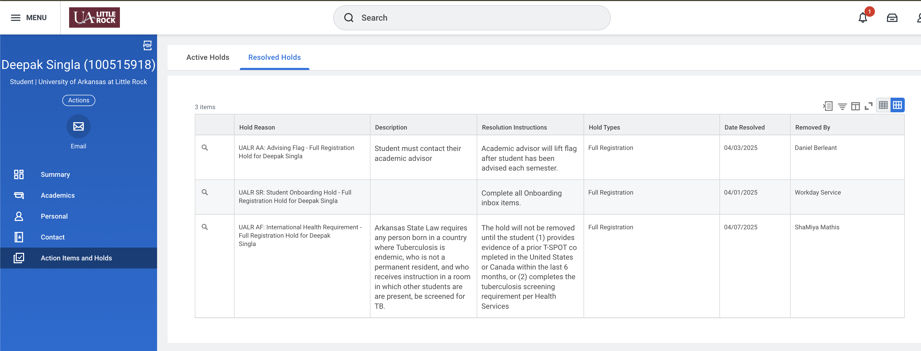

Credits

Report format has been copied from

<https://www.proquest.com/pqdtlocal1009983/docview/2902800999/fulltextPDF/C967C462E7DF4DF2PQ/1?%20Theses&accountid=14482&sourcetype=Dissertations%20>